SKILLORBIT
DATA ANALYTICS CAPSTONE PROJECT

MARKETING PERFORMANCE DASHBOARD
Project Report

Project Type | Data Analytics / Marketing Analytics
Technology | Python, Pandas, NumPy, Plotly, Streamlit, Scikit-learn
Dataset | Marketing campaign customer dataset (2,240 records, 29 columns)
Dashboard | Interactive Streamlit Marketing Performance Dashboard
Prepared For | SkillOrbit Data Analytics Capstone Project
Report Date | September 2026

GitHub: https://github.com/prakharsinghhhh/Marketing-Performance-Dashboard
Group Members: Prakhar Singh & Suneel Mahor
Contact No.: 7459899199 / 8103055990

Table of Contents
1. Executive Summary
2. Introduction
3. Problem Statement
4. Project Objectives
5. Project Scope and Workflow
6. Dataset Description
7. Tools and Technologies
8. Data Cleaning and Preprocessing
9. Feature Engineering
10. Exploratory Data Analysis
11. Key Performance Indicators
12. Customer Segmentation using K-Means
13. Dashboard Development
14. Business Insights and Recommendations
15. Dataset Limitations
16. Testing and Validation
17. Project Outputs and Deliverables
18. Conclusion
19. Future Scope
20. References
Appendix A – Dashboard Screenshots

1. Executive Summary
This project develops an interactive Marketing Performance Dashboard for analysing customer demographics, purchasing behaviour, product spending, purchase channels, campaign acceptance, latest campaign response, customer engagement, and customer segments. The project follows the workflow specified in the SkillOrbit Data Analytics Capstone Project brief: data collection, data cleaning and processing, KPI analysis, dashboard visualization, insight generation, and report creation.
The supplied dataset initially contained 2,240 customer records and 29 columns. The analytical dataset contains 2,236 customers after documented cleaning. Missing income values were imputed using the median, unrealistic birth-year records were removed, and an extreme income value above the documented threshold was excluded. Feature engineering created Age, Total Spending, Total Purchases, Total Campaign Acceptance, and Total Children.
The final analysis reports $1,354,986 in total customer spending, an average customer spending of $606, an average income of $51,953, and a latest campaign response rate of 14.94%. K-Means clustering was evaluated for K=2 through K=8 and K=2 was selected because it produced the highest silhouette score (0.381) among the tested values.

2. Introduction
Marketing analytics converts customer and campaign data into information that can support business analysis and decision-making. The SkillOrbit project brief defines the Marketing Performance Dashboard as a data analytics application intended to track, analyse, and visualize marketing campaign performance, customer engagement, channel behaviour, and business metrics through an interactive dashboard.
This implementation focuses on the fields that are actually available in the supplied customer marketing dataset. In particular, Web, Catalog, and Store are treated as purchase channels; they are not interpreted as digital advertising channels. Similarly, the Response field is treated as the latest campaign response, not as a general advertising sales-conversion metric.

3. Problem Statement
Raw marketing datasets contain many demographic, behavioural, purchase, and campaign variables. Without systematic preprocessing and visualization, it is difficult to understand customer value, campaign acceptance, product preferences, purchasing channels, and differences between customer groups.
The project therefore addresses the following practical problem: how can a customer marketing dataset be cleaned, analysed, segmented, and presented through an interactive dashboard so that important patterns and business-relevant observations can be understood efficiently?

4. Project Objectives
- Load and inspect the supplied marketing campaign dataset.
- Identify and handle missing values, duplicates, invalid birth years, and extreme income values.
- Create analytical features such as Age, Total Spending, Total Purchases, and Total Campaign Acceptance.
- Perform exploratory analysis of customer demographics, income, spending, product categories, purchase channels, and campaign response.
- Calculate valid customer and campaign KPIs from the available dataset.
- Use K-Means clustering to identify customer segments with similar behavioural characteristics.
- Develop an interactive Streamlit dashboard with filters, KPI cards, charts, segmentation analysis, and a data explorer.
- Generate evidence-based business insights and recommendations without inventing unavailable advertising metrics.

5. Project Scope and Workflow
The implementation follows the workflow defined in the SkillOrbit project brief.
Step | Stage | Implementation
1 | Marketing Data Collection | Load the supplied customer marketing dataset.
2 | Data Cleaning & Processing | Handle missing values, invalid records, dates, duplicates, and outliers.
3 | KPI Analysis | Calculate customer, spending, purchase, response, acceptance, complaint, and recency KPIs.
4 | Dashboard Visualization | Present interactive charts, filters, KPI cards, segmentation and data exploration.
5 | Insight Generation | Translate observed patterns into quantitative observations and recommendations.
6 | Report Creation | Document methodology, results, dashboard, insights, limitations and conclusion.

6. Dataset Description
The project uses the supplied semicolon-separated marketing campaign customer dataset. The source files provided for the project contain the same customer marketing structure in CSV/XLSX form. The supplied project brief permits marketing datasets from sources such as sample analytics datasets, Kaggle, social-media campaign datasets, or self-created datasets; the specific external origin of this supplied dataset is not stated in the project materials, so no external source is claimed here.
Dataset item | Value
Initial records | 2,240
Initial columns | 29
Missing Income values | 24
Duplicate rows | 0
Birth years below 1920 | 3
Income values above $200,000 | 1
Final analytical records | 2,236
Final analytical columns before segment label | 34
Age reference year | 2014

6.1 Important Dataset Variables
Category | Variables
Demographic | Year_Birth, Education, Marital_Status, Income, Kidhome, Teenhome
Customer activity | Recency, NumWebVisitsMonth
Product spending | MntWines, MntFruits, MntMeatProducts, MntFishProducts, MntSweetProducts, MntGoldProds
Purchase channels | NumWebPurchases, NumCatalogPurchases, NumStorePurchases
Campaign variables | AcceptedCmp1–AcceptedCmp5, Response
Customer issue indicator | Complain

7. Tools and Technologies
Technology | Purpose
Python | Primary programming language for data processing, analysis and dashboard logic.
Pandas | Data loading, cleaning, feature engineering, aggregation and tabular analysis.
NumPy | Numerical operations and supporting calculations.
Plotly | Interactive charts used in the Streamlit dashboard.
Scikit-learn | StandardScaler, K-Means clustering and silhouette-score evaluation.
Streamlit | Interactive dashboard application and filter-based exploration.
Jupyter Notebook | Documented analytical workflow and reproducible analysis.

8. Data Cleaning and Preprocessing
Duplicate handling: The raw dataset contains 0 duplicate rows, so no records were removed for duplication.
Date conversion: Dt_Customer was converted from text to datetime format using error-tolerant parsing.
Missing Income: 24 missing Income values were filled with the median income.
Invalid birth years: 3 records with Year_Birth below 1920 were removed to avoid unrealistic age values.
Extreme Income: 1 extreme income record above $200,000 was removed according to the documented cleaning rule.
Reference year: Age was calculated as 2014 minus Year_Birth, matching the notebook and dashboard definition.

9. Feature Engineering
Feature | Definition
Age | 2014 − Year_Birth
Total Spending | MntWines + MntFruits + MntMeatProducts + MntFishProducts + MntSweetProducts + MntGoldProds
Total Purchases | NumWebPurchases + NumCatalogPurchases + NumStorePurchases
Total Campaign Acceptance | AcceptedCmp1 + AcceptedCmp2 + AcceptedCmp3 + AcceptedCmp4 + AcceptedCmp5
Total Children | Kidhome + Teenhome

10. Exploratory Data Analysis
Exploratory analysis was performed across demographic, financial, purchasing, engagement, and campaign variables. The dashboard visualizes these analyses interactively and updates the displayed values when filters are changed.
- Education distribution: Graduation is the largest category with 1,126 customers.
- Marital-status distribution: Married is the largest recorded category with 864 customers.
- Total spending is $1,354,986; Wines contribute $680,029, the largest product-category total.
- Store purchases are the largest purchase-channel volume at 12,959 purchases.
- The latest campaign response consists of 334 responding customers and 1,902 non-responding customers.
- PhD customers have the highest observed latest-campaign response rate at 20.82% among the listed education groups.
- The correlation between monthly web visits and web purchases is -0.06, indicating a weak negative association in this dataset; correlation does not establish causation.

11. Key Performance Indicators
The dashboard uses KPIs that can be calculated from the available dataset. The source data does not contain advertising impressions, ad clicks, advertising cost, customer reach, or advertising revenue. Therefore, traditional CTR, advertising conversion rate, and ROI are not fabricated.
KPI | Value | Definition
Total Customers | 2,236 | Number of customers after documented cleaning.
Average Income | $51,953 | Mean customer income.
Average Spending | $606 | Mean total spending per customer.
Total Spending | $1,354,986 | Sum of spending across the six product categories.
Average Purchases | 12.5 | Mean web + catalog + store purchases.
Campaign Response Rate | 14.94% | Latest campaign response rate from Response.
Campaign Acceptance Rate | 5.96% | Accepted previous campaigns divided by five campaign opportunities per customer.
Complaint Rate | 0.89% | Share of customers with Complain = 1.
Average Recency | 49.1 days | Mean recency value.

12. Customer Segmentation using K-Means
Customer segmentation was performed using K-Means clustering. The clustering feature set contains Income, Recency, Total Spending, Web Purchases, Catalog Purchases, Store Purchases, and Total Campaign Acceptance. Total Purchases was intentionally not included alongside its three component purchase-channel variables, because doing so would give purchase volume additional weight.
The variables were standardized with StandardScaler because they operate on different numeric scales. Candidate values K=2 through K=8 were evaluated. The elbow method was used for visual inspection, while the silhouette score was used by the implementation to select the final K.
K | Silhouette score
2 | 0.3806
3 | 0.3498
4 | 0.2506
5 | 0.2370
6 | 0.2342
7 | 0.2384
8 | 0.2355
K=2 produced the highest silhouette score (0.3806) among the tested values and was therefore used for the final segmentation.
Segment | Customers | Avg Income | Avg Recency | Avg Spending | Avg Purchases | Prev. Campaign Acceptance | Latest Response
Segment 0 | 1023 | $69,823 | 49.1 | $1,157 | 19.3 | 10.99% | 21.60%
Segment 1 | 1213 | $36,881 | 49.1 | $141 | 6.9 | 1.71% | 9.32%
The segment labels (0 and 1) are model-generated labels and do not represent predefined customer personas. Their interpretation should be based on the measured profile rather than on the label number itself.

13. Dashboard Development
The final dashboard is implemented in Streamlit. It provides a consistent analytical interface with a sidebar for Education, Marital Status, Customer Segment, Age, and Income filters. The dashboard contains seven main tabs: Overview, Customer Analysis, Spending & Channels, Campaign Performance, Segmentation, Business Insights, and Data Explorer.
Dashboard section | Purpose
Overview | Headline KPIs and demographic distributions.
Customer Analysis | Income/spending relationships, age and engagement-oriented analysis.
Spending & Channels | Product-category spending and Web/Catalog/Store purchase behaviour.
Campaign Performance | Previous campaign acceptance, latest response, and response comparisons.
Segmentation | K-Means segment distribution, profiles, spending, purchases, and response.
Business Insights | Dynamic observations and recommendations calculated from the filtered data.
Data Explorer | Interactive customer-level table with selectable columns and CSV download.
The dashboard was checked against the final notebook definitions so that cleaning rules, KPI definitions, age reference year, and K-Means feature selection remain consistent between the analytical workflow and the interactive application.
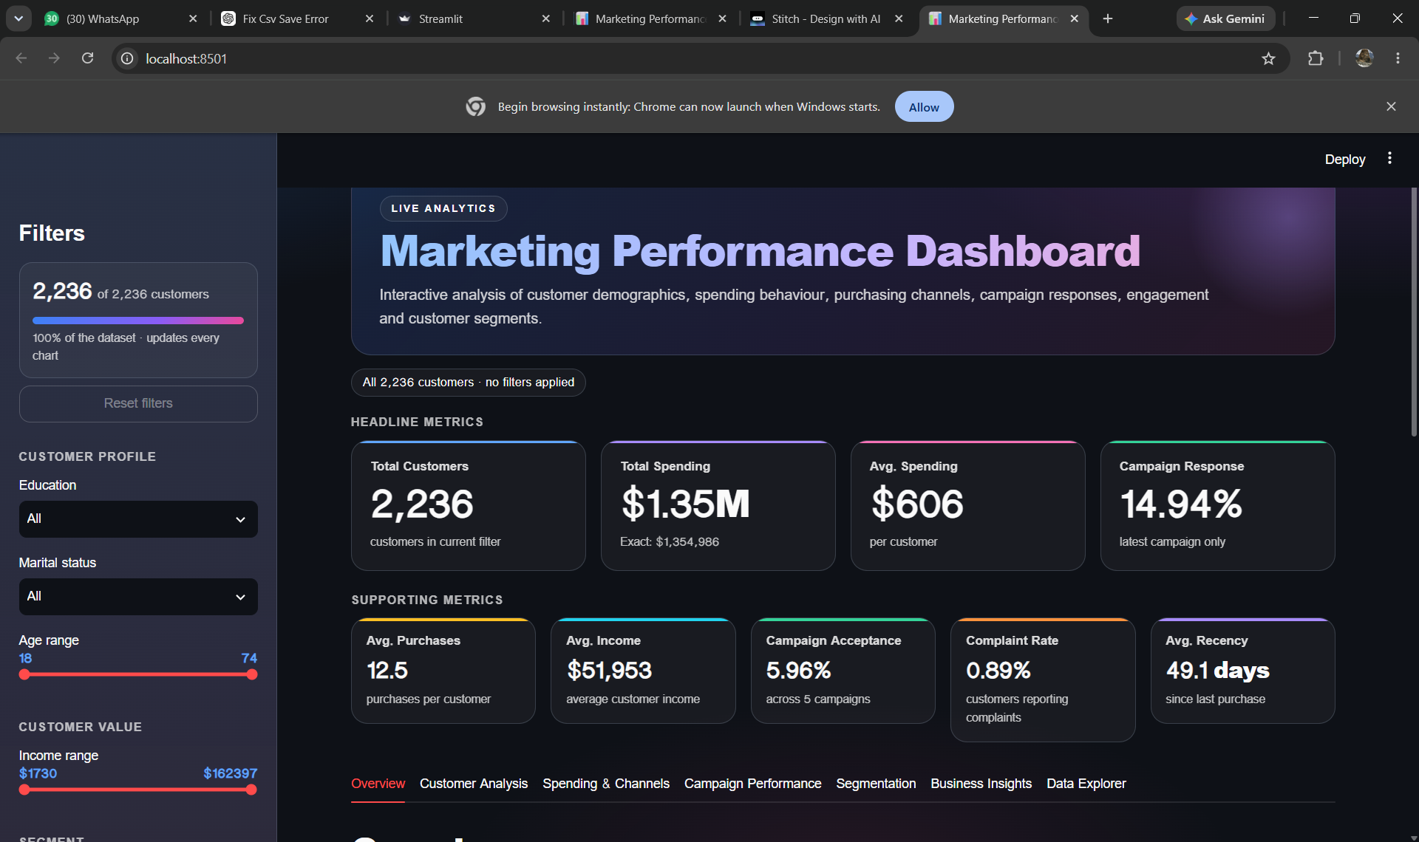
Figure 1. Dashboard overview and headline KPIs.
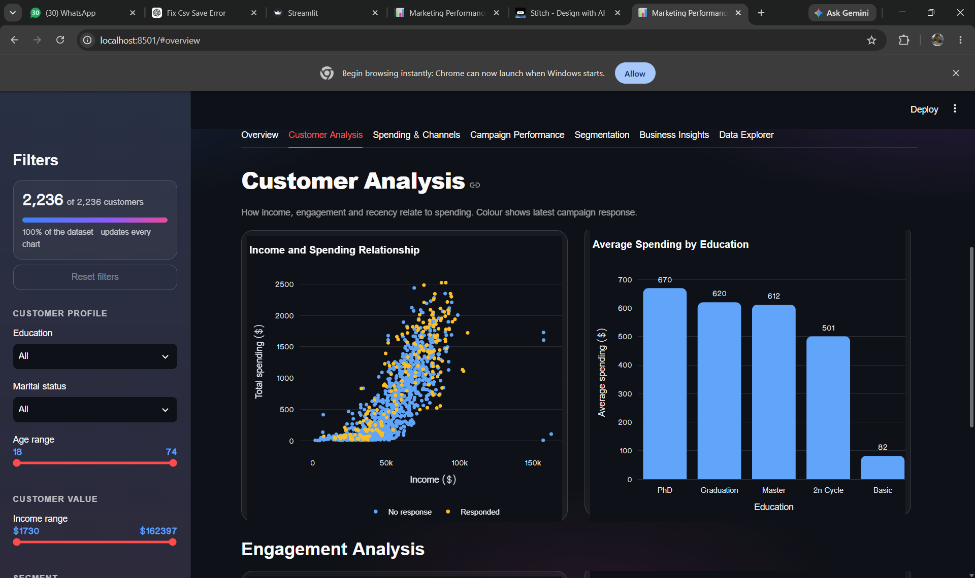
Figure 2. Customer analysis – income/spending and education comparisons.
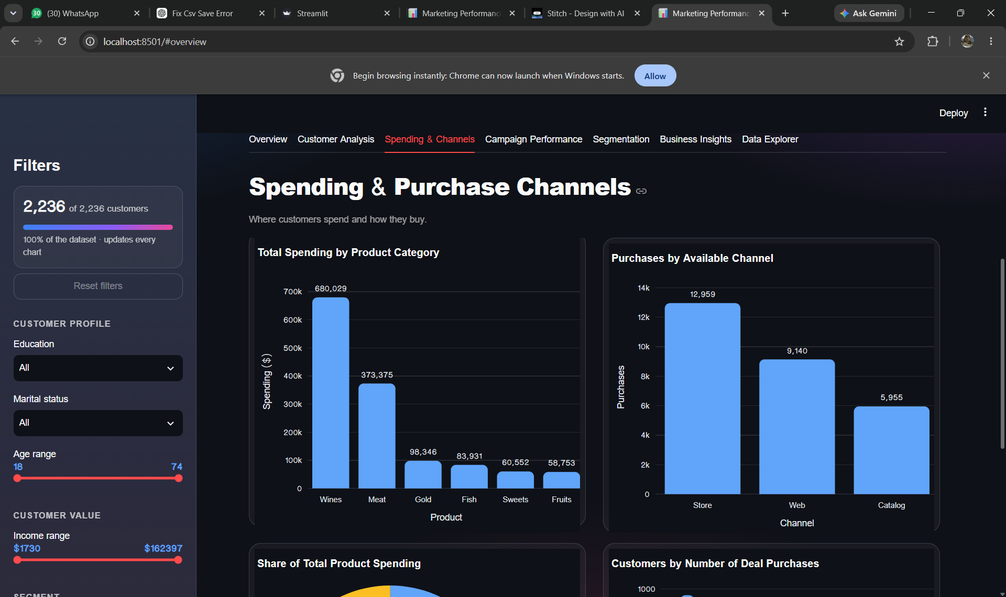
Figure 3. Spending and purchase-channel analysis.
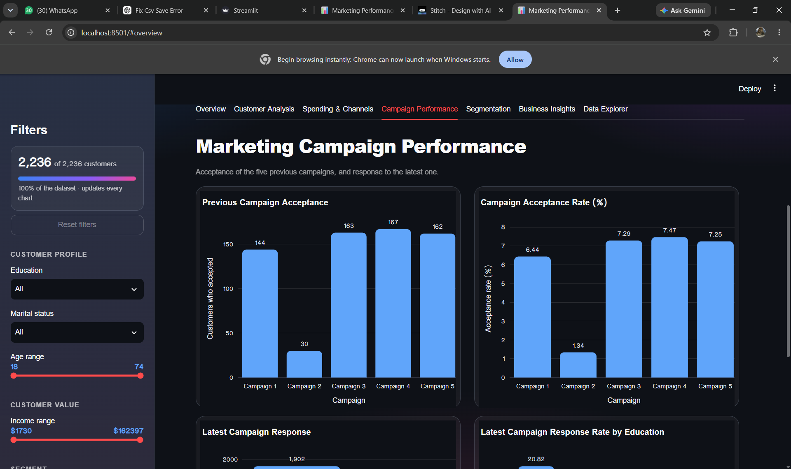
Figure 4. Campaign performance – previous campaign acceptance.
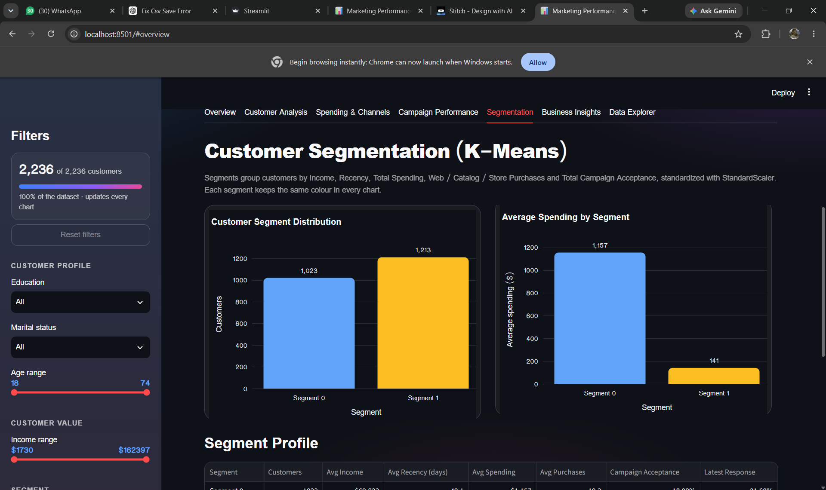
Figure 5. K-Means customer segmentation.
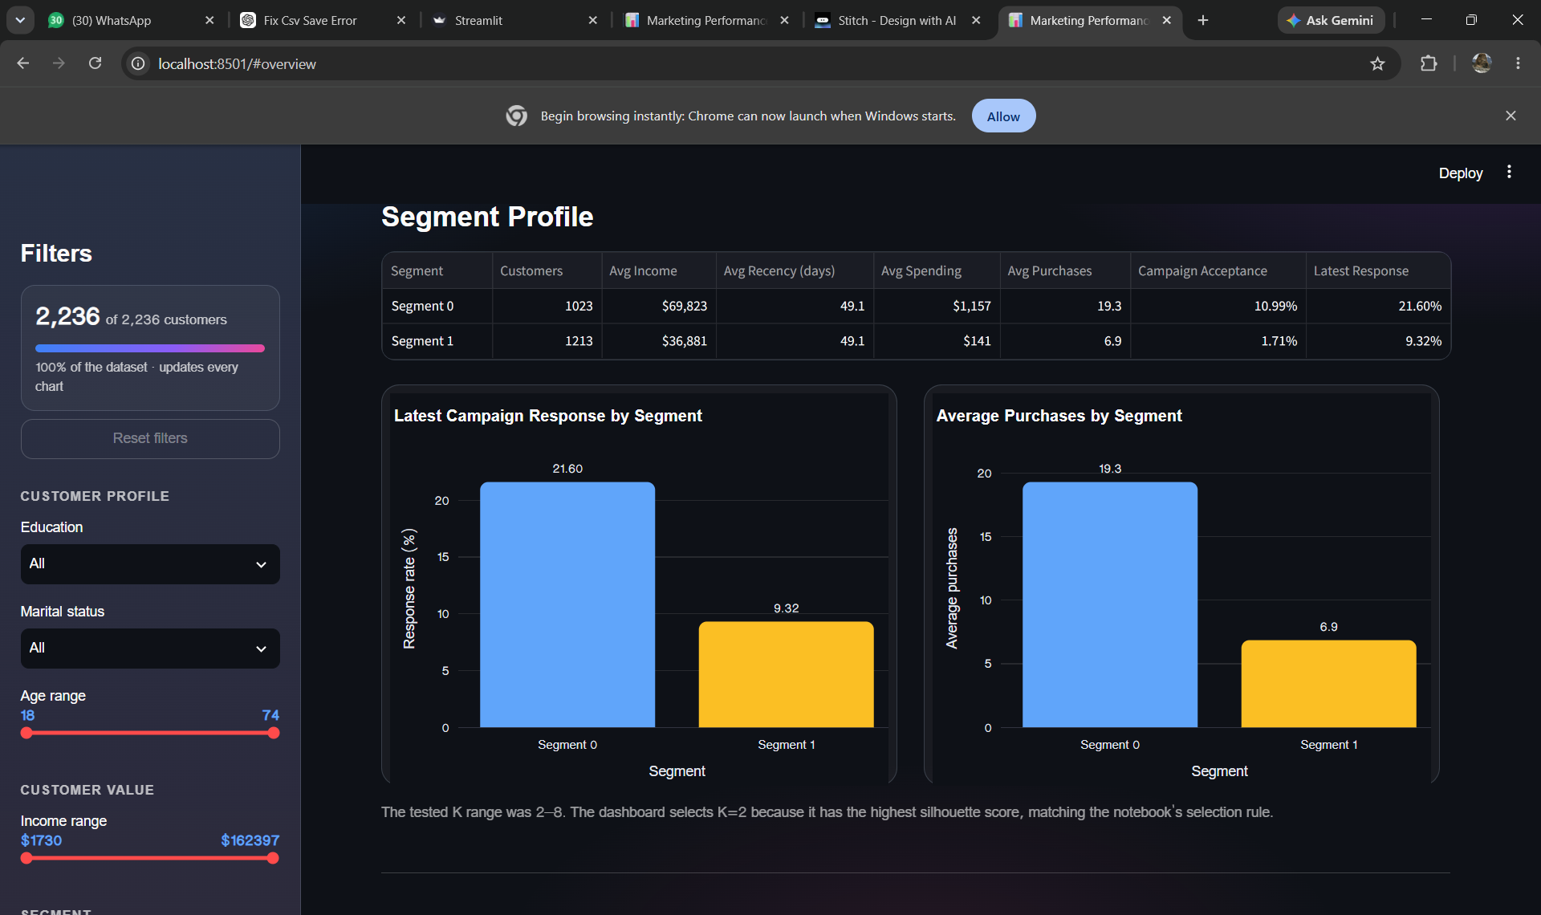
Figure 6. Segment profile and segment-level behaviour.
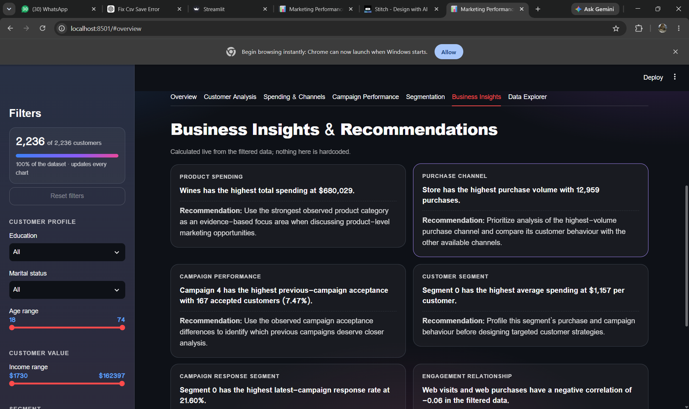
Figure 7. Business Insights and Recommendations.
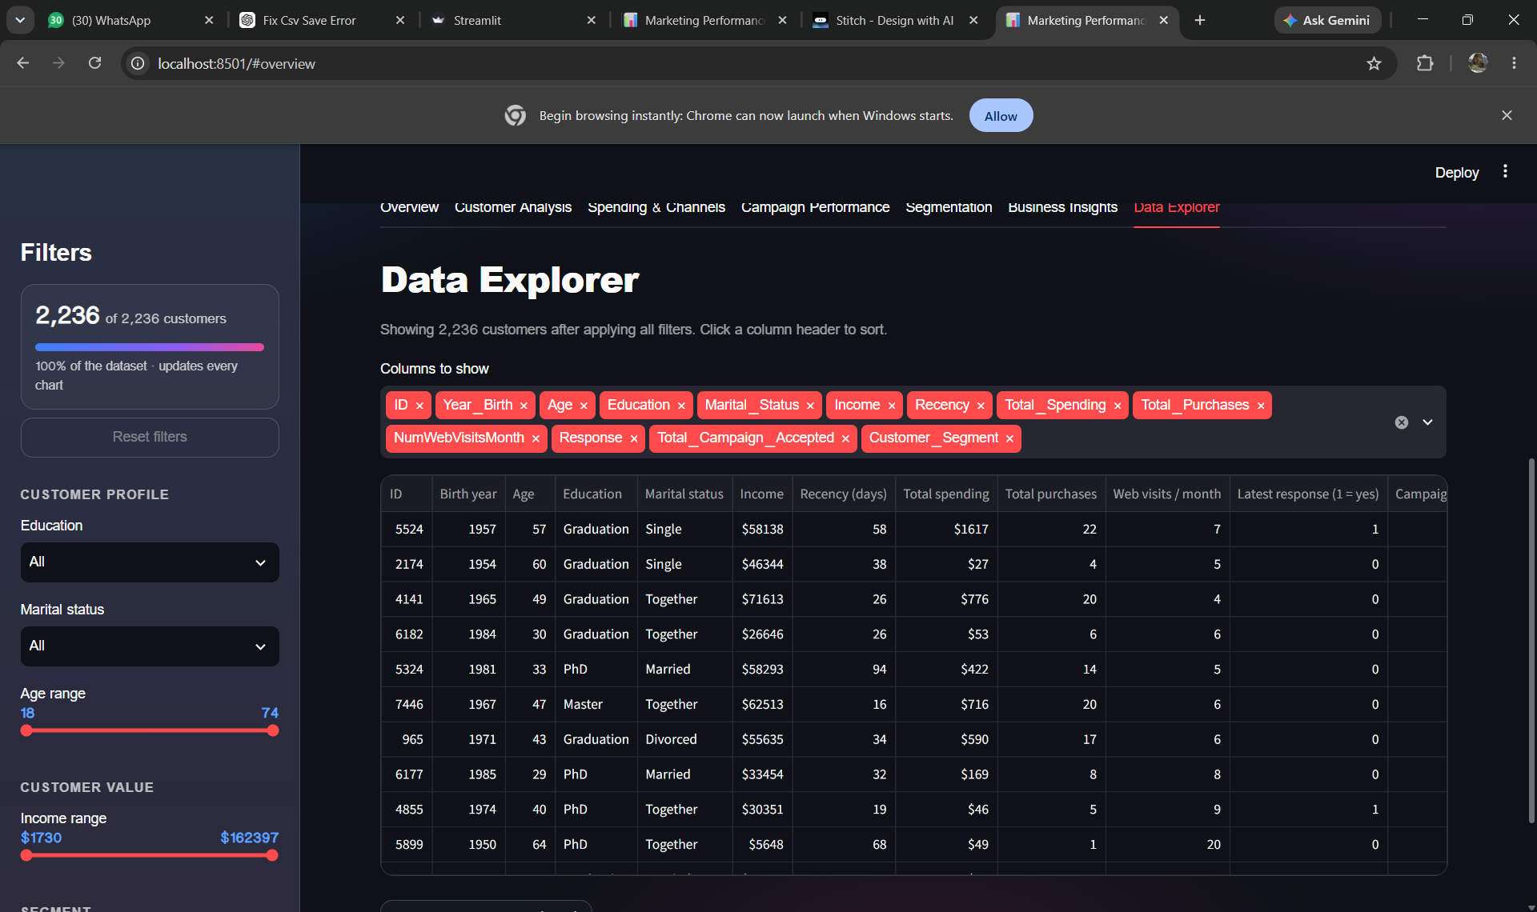
Figure 8. Data Explorer with customer-level records.

14. Business Insights and Recommendations
The following insights are calculated from the cleaned dataset and are also reflected dynamically in the dashboard. They describe observed patterns and should not be interpreted as causal effects.
Product spending: Wines have the highest total spending at $680,029.
Recommendation: Use the strongest observed product category as an evidence-based focus area for further product-level analysis.
Purchase channel: Store has the highest purchase volume with 12,959 purchases.
Recommendation: Compare the behaviour of store purchasers with web and catalog purchasers before designing channel-specific strategies.
Campaign performance: Campaign 4 has the highest previous-campaign acceptance with 167 accepted customers (7.47%).
Recommendation: Use the observed differences between previous campaigns to identify campaigns that deserve closer analysis.
Customer segment: Segment 0 has the highest average spending at $1,157 per customer.
Recommendation: Profile this segment's purchasing and campaign behaviour before designing targeted customer strategies.
Latest campaign response: Segment 0 has the highest latest-campaign response rate at 21.60%.
Recommendation: Compare segment characteristics to understand which measured customer attributes are associated with campaign response.
Engagement relationship: Monthly web visits and web purchases have a correlation of -0.06.
Recommendation: Treat this as an observed association rather than proof that web visits cause purchases.

15. Dataset Limitations
- The dataset does not contain advertising impressions.
- The dataset does not contain advertising click counts.
- Advertising cost/spend is not provided.
- Customer reach is not provided.
- Advertising revenue is not provided.
- Therefore genuine advertising CTR, advertising conversion rate, and ROI cannot be calculated directly.
- Web/Catalog/Store are purchase channels, not digital advertising channels.
- Response represents the latest campaign response available in the dataset and is not treated as a true advertising sales-conversion rate.
- Correlation analysis describes association and does not establish causation.
- K-Means segment labels are model-generated and should not be treated as fixed business personas.
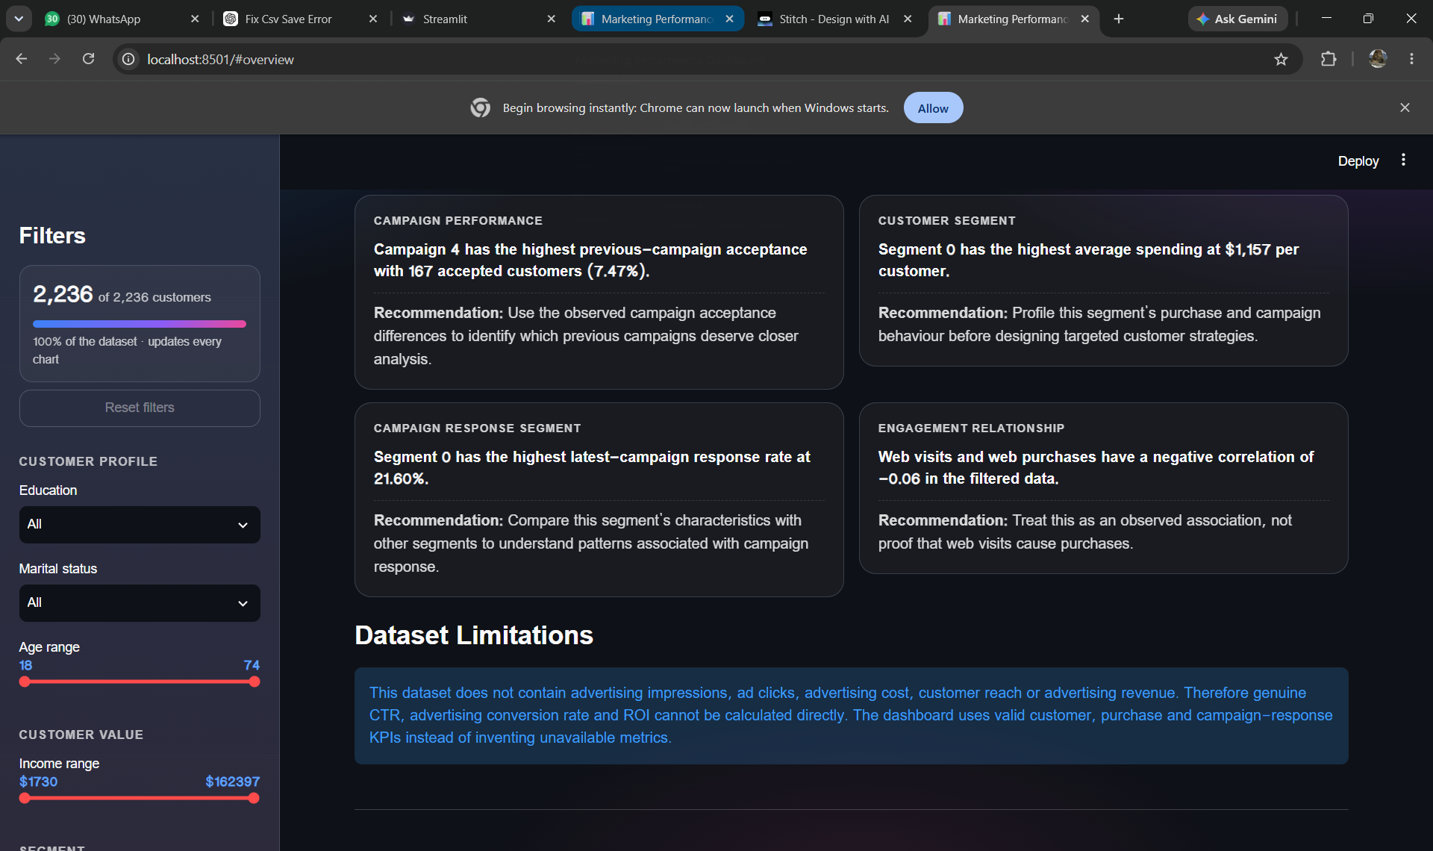
Figure 9. Dashboard dataset limitations statement.

16. Testing and Validation
Test area | Validation result
Data loading | Dashboard successfully loads the supplied semicolon-separated CSV dataset.
Cleaning consistency | Dashboard cleaning rules match the final analytical notebook.
KPI consistency | Dashboard shows 2,236 customers and the same KPI definitions used in the notebook.
Filtering | Education, Marital Status, Customer Segment, Age and Income filters are available and update dashboard content.
Campaign analysis | Previous campaign acceptance and latest response are displayed separately.
Segmentation | K=2 is selected using the highest silhouette score among K=2..8.
Business insights | Insight cards are calculated from the filtered data rather than being hardcoded.
Data Explorer | Customer-level records can be viewed, columns can be selected, and filtered data can be downloaded as CSV.

17. Project Outputs and Deliverables
Deliverable | Status / Description
Source code | Streamlit dashboard Python file.
Analytical notebook | market_fixed_final.ipynb containing cleaning, EDA, KPI analysis and K-Means workflow.
Dataset | Marketing campaign CSV/XLSX source data used for the analysis.
Project report | This document.
PPT presentation | To be prepared as the concise visual presentation of the project.
Dashboard screenshots | 14 screenshots are available and have been incorporated into this report where relevant; the remaining screenshots can be kept as an appendix/evidence set.
GitHub repository | To be added during the repository/deployment stage.
Deployment link | To be added after deployment.
Demo video | To be recorded after the final dashboard and deployment are ready.

18. Conclusion
The Marketing Performance Dashboard demonstrates a complete customer marketing analytics workflow from raw data preparation to interactive visualization and customer segmentation. The project cleaned the supplied data, engineered analytical variables, evaluated customer and campaign behaviour, calculated valid KPIs, and implemented K-Means clustering.
The cleaned dataset contains 2,236 customers. Total customer spending is $1,354,986, the average spending is $606, and the latest campaign response rate is 14.94%. K=2 was selected for segmentation using the highest silhouette score among the tested values. The resulting dashboard provides interactive filters and multiple analytical views.
A key strength of the implementation is that it respects the limits of the available data. Metrics that require advertising impressions, clicks, costs, reach, or revenue were not invented. Instead, the project reports customer, purchase, campaign-response, and segmentation measures that can be calculated directly from the dataset.

19. Future Scope
- Integrate a dataset containing advertising impressions, clicks, ad spend, reach and revenue to support genuine CTR, conversion and ROI calculations.
- Add time-based campaign analysis when campaign dates are available.
- Connect the dashboard to a database for larger datasets.
- Add role-based or organization-level access if used beyond an academic setting.
- Add automated scheduled report generation.
- Evaluate alternative clustering approaches and stability across multiple samples or random seeds.
- Deploy the Streamlit application through a supported hosting platform and connect the final GitHub repository.

20. References
1. SkillOrbit Data Analytics Capstone Project brief – Marketing Performance Dashboard.
2. Supplied marketing campaign customer dataset (CSV/XLSX).
3. Project analytical notebook: market_fixed_final.ipynb.
4. Project dashboard source code: appppppp.py.

Appendix A – Dashboard Screenshots
The following screenshots document the final interactive dashboard. They are retained as evidence of the implemented dashboard views and are intentionally kept in the report so that the submission can be understood without requiring access to the local Streamlit application.
Figure A1. Dashboard landing/overview with headline KPIs.
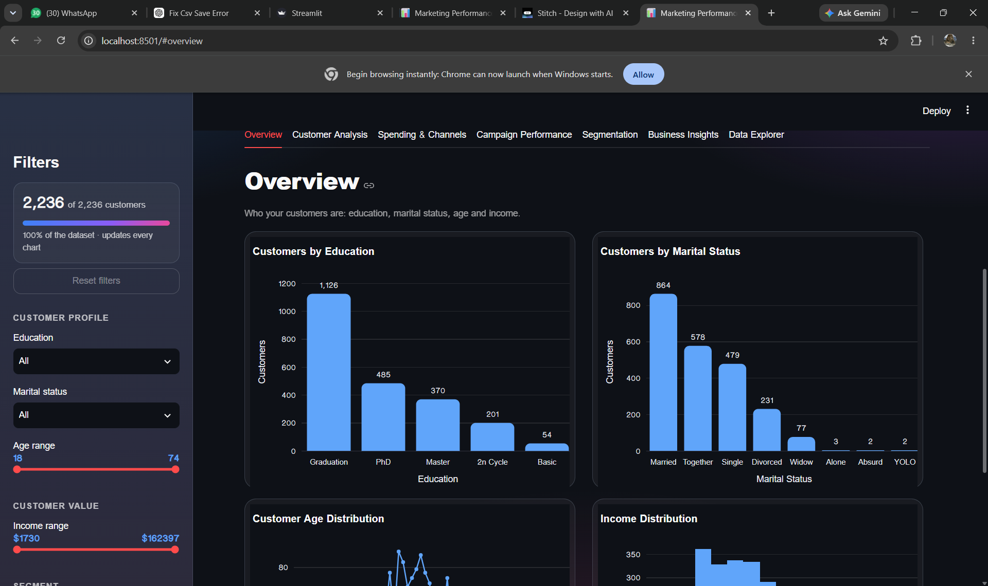
Figure A2. Overview – customer distribution by education and marital status.
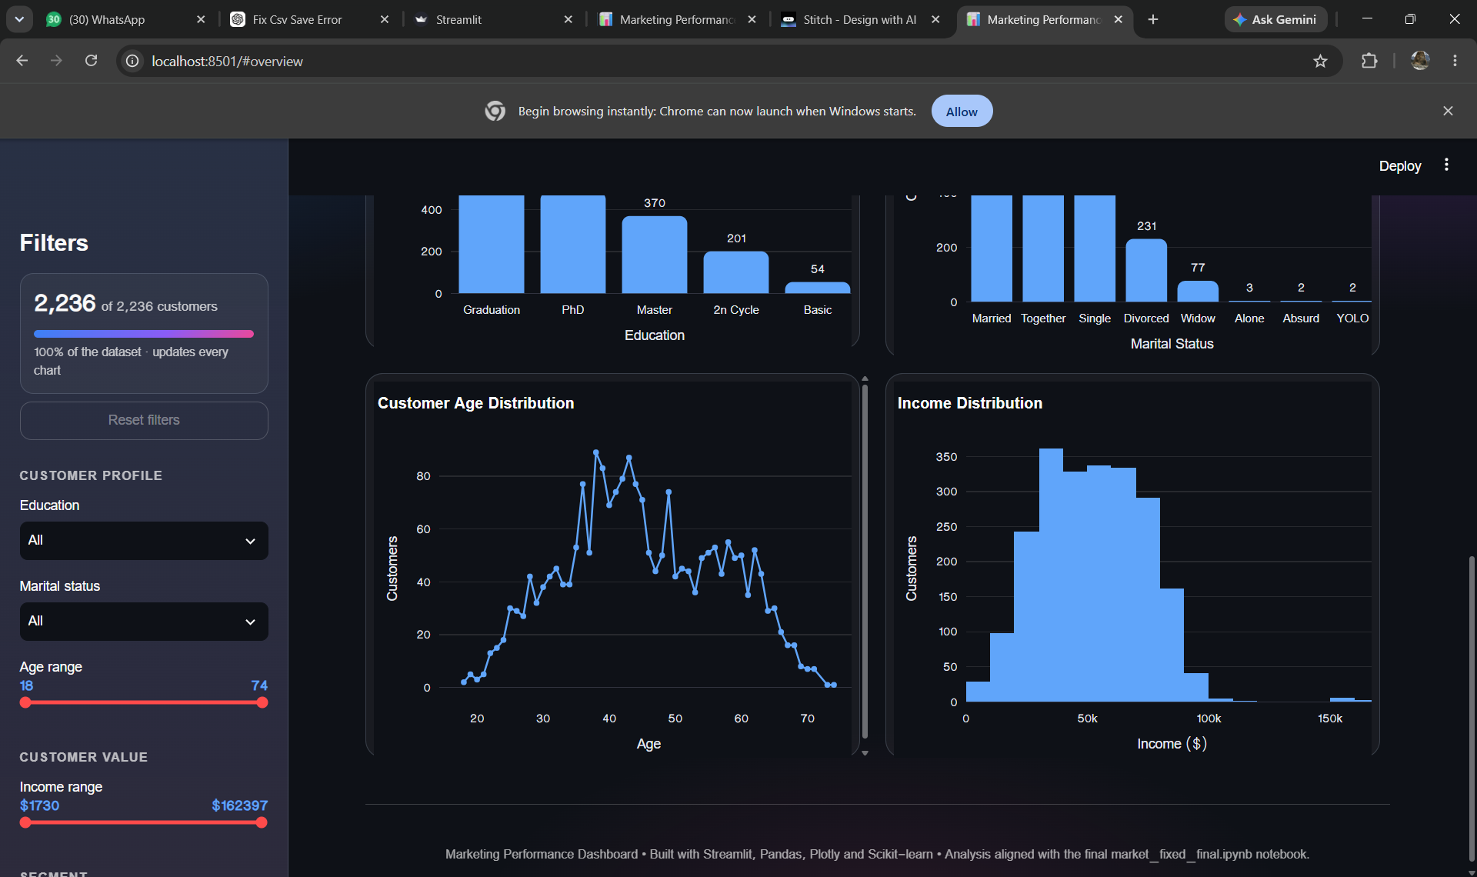
Figure A3. Overview – customer age and income distributions.
Figure A4. Customer Analysis – income/spending and education comparison.
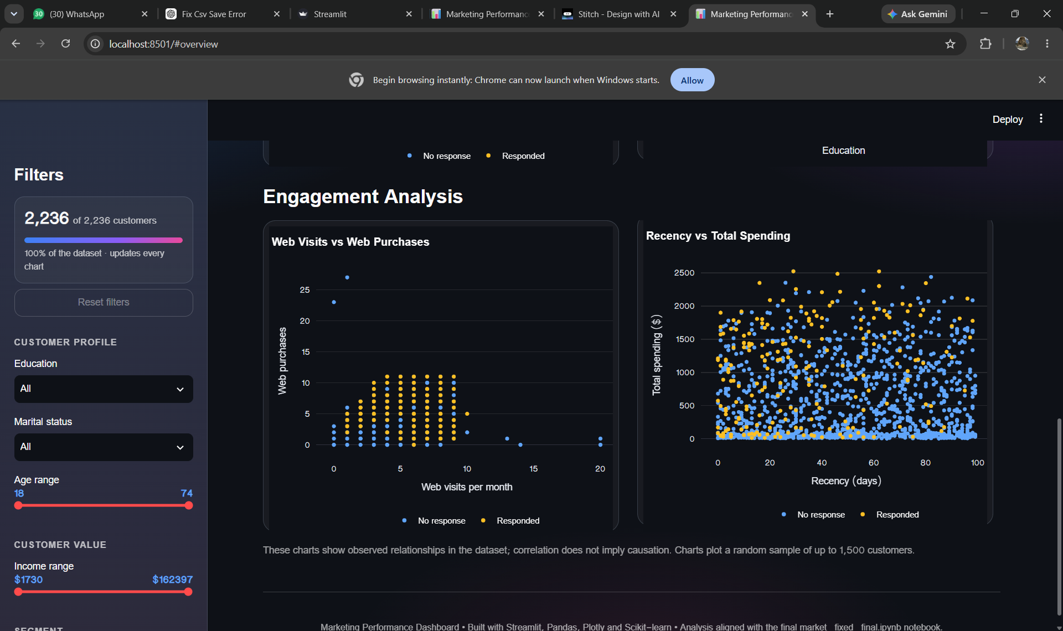
Figure A5. Customer Analysis – engagement relationships.
Figure A6. Spending & Purchase Channels.
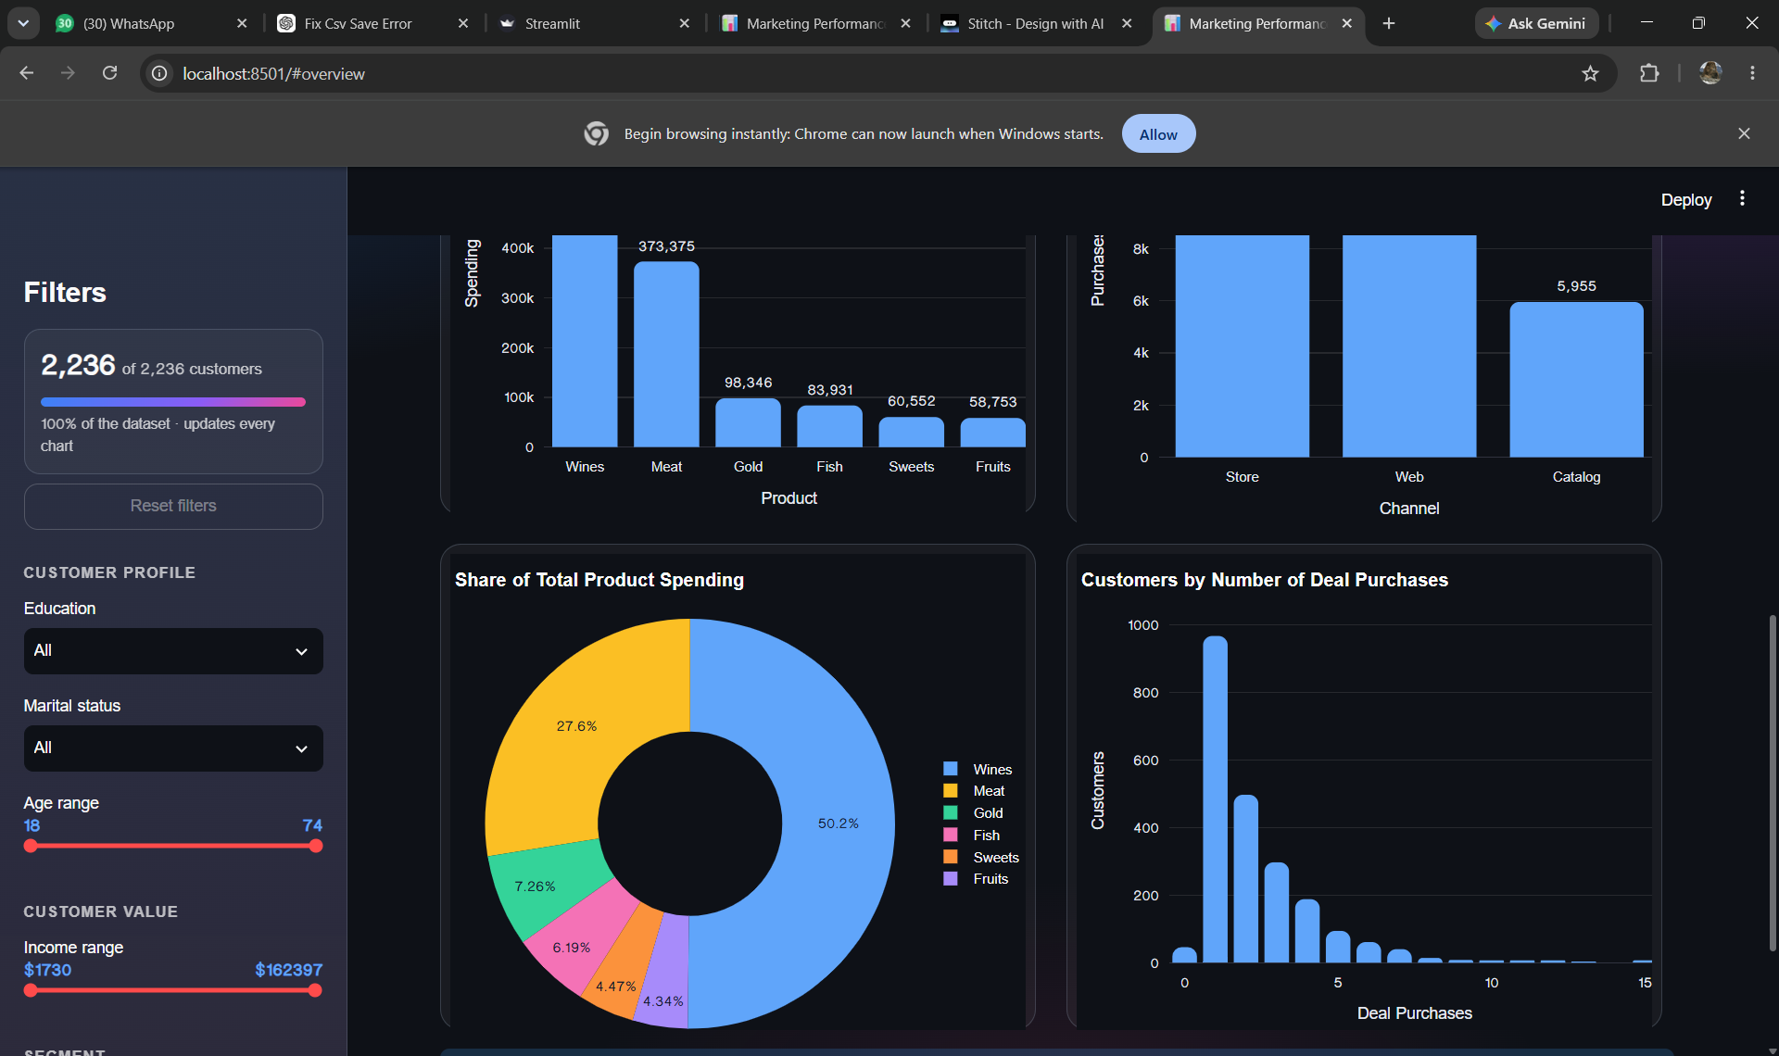
Figure A7. Product spending share and deal-purchase behaviour.
Figure A8. Campaign Performance – previous campaign acceptance.
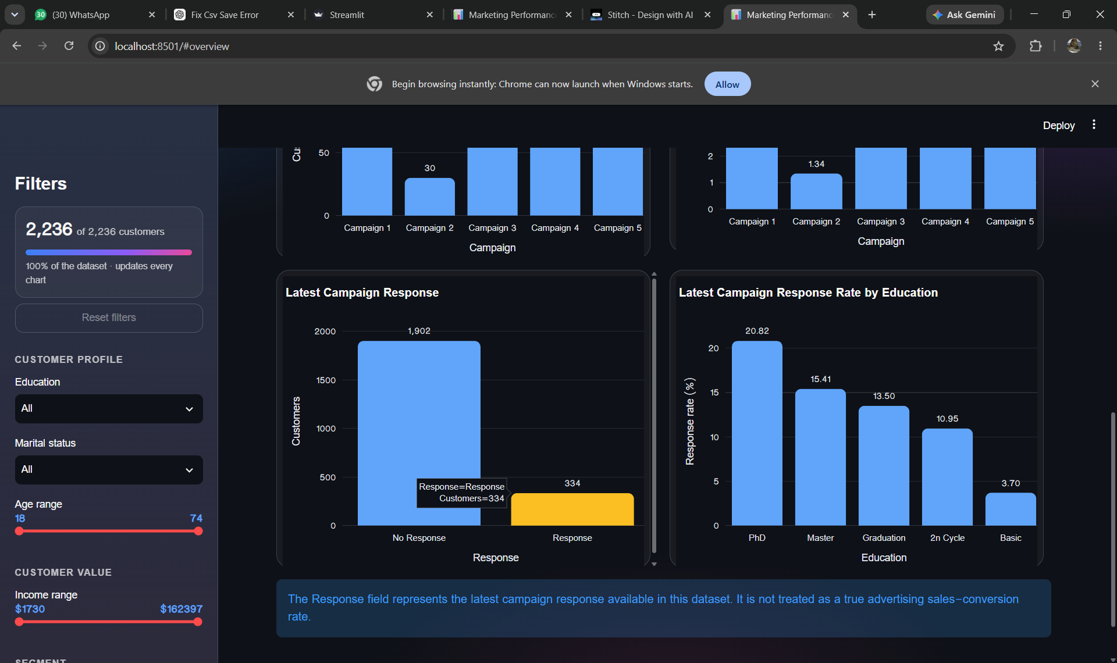
Figure A9. Campaign Performance – latest response and response by education.
Figure A10. K-Means Customer Segmentation.
Figure A11. Segment Profile and segment-level behaviour.
Figure A12. Business Insights & Recommendations.
Figure A13. Dataset limitations and evidence-based recommendations.
Figure A14. Data Explorer with customer-level records.

